Justin Winfield  
CSC 424 – Spring 2018  
Assignment 4

**Problem 2**

Using Cluster Analysis technique with K-medoids between all the metric variables in the Divvy and weather data it appears there’s need to be additional work that needs to be done or the results appears to be inconclusive.

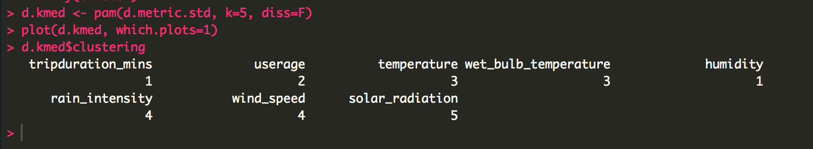



**Problem 3**

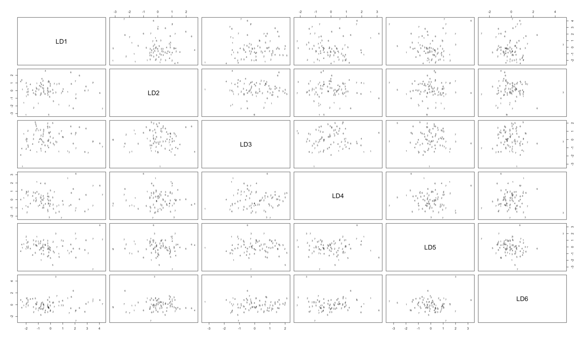

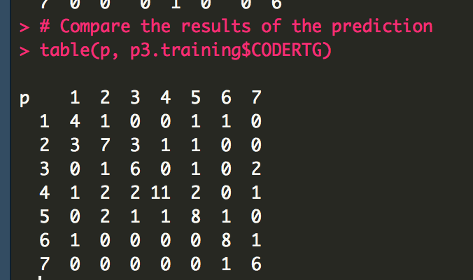

1. The performance on the training data shows 31 misclassified of the bond ratings out of 81 samples, which is approximately 38.27% error rate. In the 1-Coded bond, there were 3 misclassified, 8 in 2-coded bond rating, 4 in 3-coded bond rating, 8 in 4-coded bond rating, 5 in 5-coded bond rating, 2 in 6-coded bond rating, and 1 in 7-coded bond rating. Therefore, the percent of correct classification is 61.73%



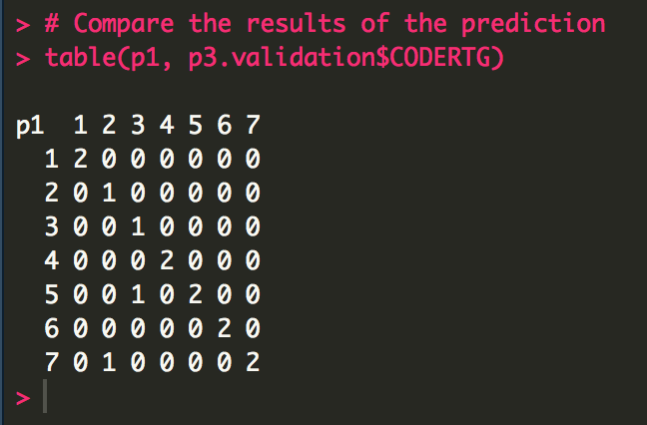

1. Looks like the validation has removed some of the miscalculation but also reduced the amount of samples in the dataset